  *INSERT NUMBER HERE* | *INSERT NUMBER HERE* | *INSERT NUMBER HERE* | *INSERT NUMBER HERE*
*INSERT NUMBER HERE* | *INSERT NUMBER HERE* | *INSERT NUMBER HERE* | *INSERT NUMBER HERE*

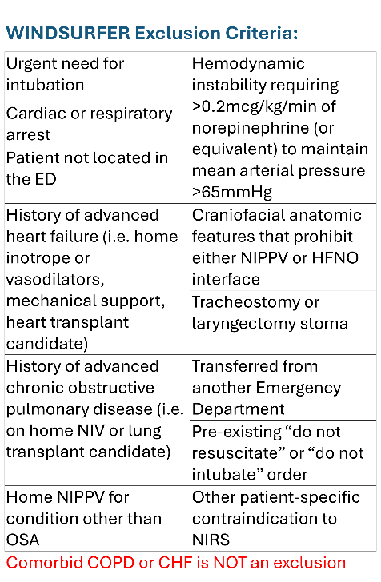 | 

