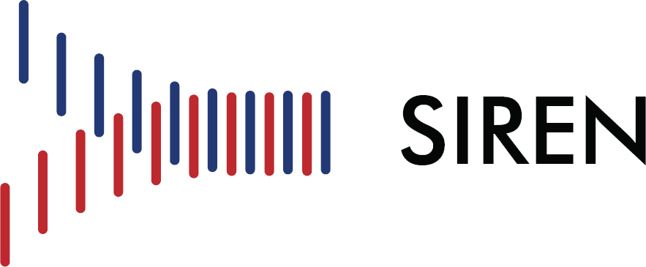
Clinical Coordinating Center University of Michigan Lobby H, Suite H3100
24 Frank Lloyd Wright Drive Ann Arbor, MI 48106
734-232-2142

NIH SIREN Emergency Clinical Trials Network

Documentation: Investigator Meeting Attestation

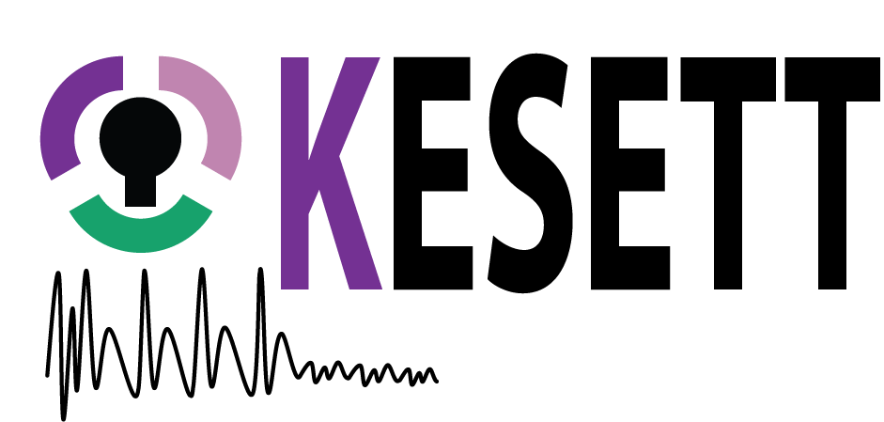

I attest that I attended the Investigator Meeting for the KESETT trial on October 16th and 17th, 2025 in its entirety. Attendance at this meeting fulfills the requirement for the protocol, data, and regulatory training.

Sincerely,
Print Name: _____________________________________________

Title: _____________________________________________

Date of Completion: _____________________________________________

