Enrollment Checklist
Screening: Date/Time of injury: Time of arrival at enrolling hospital:
Confirm Eligibility using Inclusion/Exclusion criteria: (all boxes must be checked to confirm eligibility)
Inclusion | Check if YES | Exclusion | Check if NO
Non-penetrating TBI |  | Bilaterally absent pupil response (off paralytics)
GCS 3—8 off paralytics |  | Contraindication to placement of intracranial monitors
Evidence of intracranial trauma on CT scan |  | Treatment of brain tissue oxygen values prior to randomization (values must be masked to clinical team)
Able to place intracranial monitors/randomize within 6 hours of arrival at enrolling site |  | Planned use of devices which may unblind treating physicians to brain tissue hypoxia
Able to place intracranial monitors/randomize within 12 hours of injury |  | Systemic sepsis at screening
Age>14 years |  | Refractory hypotension
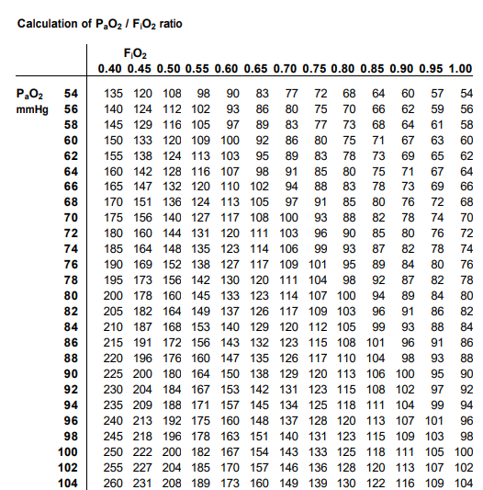 |  | Refractory systemic hypoxia
 |  | PaO2/FiO2 ratio less than 200
 |  | Known pre-existing neurologic disease with confounding residual neuro deficits
 |  | Known inability to perform ADLs without assistance prior to injury
 |  | Known active drug/alcohol dependence that would interfere with physiological response to PbtO2 treatments
 |  | Non-survivable injury
 |  | Pregnant
 |  | Prisoner/ward of the state
 |  | Patient is wearing BOOST-3 Opt Out Bracelet

_____ Identify LAR

_____ Communicate with Neurosurgery that PbtO2 monitor cannot be connected until Study Coordinator allows (values must not be seen by clinical team prior to randomization)

_____ If LAR available, review informed consent

Enrollment:

If an LAR is available prior to the successful placement of intracranial monitoring, the patient will only be enrolled with the written informed consent of the LAR. If you get written consent, you can randomize prior to probe placement (assuming they are going to place the probe prior to the 6 hours of arrival at your hospital and within the 12 hours from injury.

Do not enroll with EFIC if the family is there before the monitor placement. If you cannot get written consent in time, do not use EFIC to enroll. You may lose the patient but this is the rule.

If an LAR is not available prior to the successful placement of intracranial monitoring, eligible patients will be enrolled using EFIC immediately after (randomize after PbtO2 monitor placement – not before placement) intracranial monitor placement.

_____ Randomize in WebDCU: Before randomization, enter the subject enrollment form, the Glasgow Coma Scale (baseline) and Inclusion/Exclusion criteria form in WebDCU.

_____ If participant is in Blinded (ICP only) arm, apply cover to Licox or program Raumedic monitor to hide PbtO2 values. Ensure that values are not visible on patient ICU monitor.

_____ Connect Moberg CNS monitor to patient ICU monitor. Ensure that ICP and PbtO2 values are transferring to CNS monitor. Make sure that PbtO2 values are blinded for participants randomized to the ICP only group.

_____ Perform FiO2 challenge per protocol.

_____ Ensure that clinical team is aware that participant is enrolled in BOOST-3 and review tier treatments, importance of initiating treatment for ICP and/or PbtO2 abnormalities within 15 minutes of abnormality.

_____ Provide clinical team with Study Coordinator contact number for any research related questions. Provide pocket reference cards to leave at bedside, if available.

_____ Review documentation standards with bedside nurse—Moberg CarePath and/or paper documentation tool.

