# C3PO Study Coordinator Guide

* Eligible subjects will present to the ED with a COVID + status already confirmed.
  + If rapid COVID tests become available for study use, we will modify study screening procedures at that time.
* EPIC In Basket will be 1 tool you can use to check for potential subjects
* ED providers may page you to check on subject eligibility as well
* ED staff will need your guidance for all items they need to complete, please be on site, or notify the treating team if you need to leave temporarily during the ED visit

# Quick reference resources

* [Protocol](https://docs.google.com/document/d/1tmbXFjQyGKw2ULwmViD6zEZMrel59_Z8mW9wx3dIDn0/edit)
* [MOP](https://docs.google.com/document/d/1WPMXNwsqAnltHMgjv6kc06mW2OQTn3bJ5kNDnMUkMFU/edit)
* [WebDCU](https://webdcu.musc.edu/login.asp) - <https://webdcu.musc.edu/login.asp> (Enrollment and Randomization)
* [EPIC Reference: Add patient to Research Study](https://bridge.ohsu.edu/cs/itg/projects/eri/_layouts/15/WopiFrame.aspx?sourcedoc=%7bB0660FFE-8F5E-48C6-9A1B-5411AEC40B21%7d&file=How%20to%20Place%20a%20Research%20Association%20on%20a%20Patient.docx&action=default)

# Review Inclusion/Exclusion Criteria (contact ED provider as needed)

Age 18 or older

Laboratory-confirmed SARS-CoV-2 infection

1 or more symptoms of COVID-19 illness

* Cough
* Shortness of breath or difficulty breathing
* Fevers
* Chills
* Repeated shaking with chills
* Muscle pain
* Headache
* Sore throat
* New loss of taste or smell

At least 1 risk factor for severe COVID-19 illness

* Age ≥50years
* Hypertension
* Diabetes
* Coronary Artery Disease
* Chronic lung disease
* Chronic kidney disease
* Immunosuppressed
* Sickle cell disease
* Obesity (BMI>30)

Clinical team confirms patient is stable for outpatient management (discharge home) w/o new supplemental O2

Clinical team confirms patient can receive up to 250ml of intravenous fluid

Not a prisoner/ward of the state

*Coordinator may want to double check the below criteria with subject during consent conversation:*

No prior adverse reactions to blood product transfusion

No blood products within the past 120 days

Not enrolled in another interventional trial for COVID-19 illness

No Religious, social, or other contraindication to receiving blood products

## **If subject meets eligibility criteria, approach for consent.**

* English and Spanish consent forms are available in the econsent platform
  + C3PO also requires an OHSU HIPAA form to be completed. This is also in the econsent platform in English and Spanish
* [Econsent link](https://bit.ly/C3POTest)
* If they consent
  + Request **Type & Screen Order (only)** using order*IRB 21734- C3PO (Research Emergency Medicine)* in EPIC (Notify ED provider to submit order – ***you may need to help ED provider locate the pending order***)

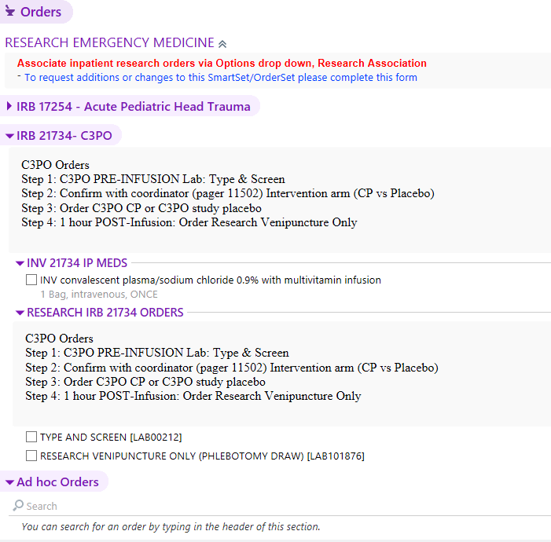

**This section only until patient is randomized.**

* + **When RN draws blood for type & screen – request pre-intervention blood sample also be collected**
    - Use pre-labeled C3PO blood draw kit for research sample (*Stored in TRG call room*)
    - Complete Drug Study Requisition form and place in biohazard bag with research blood sample
    - Send both samples to the Core Lab through the tubing system. **Be sure to send the type & screen, and research sample in separate bags.**

## **Log into** [**WebDCU**](https://webdcu.musc.edu/login.asp)

* Confirm compatible CP is available in system (i.e. both low titer A & O in house).
  + C3PO🡪Project Management🡪Convalescent Plasma Inventory (Group O & Group A Inventory Columns)

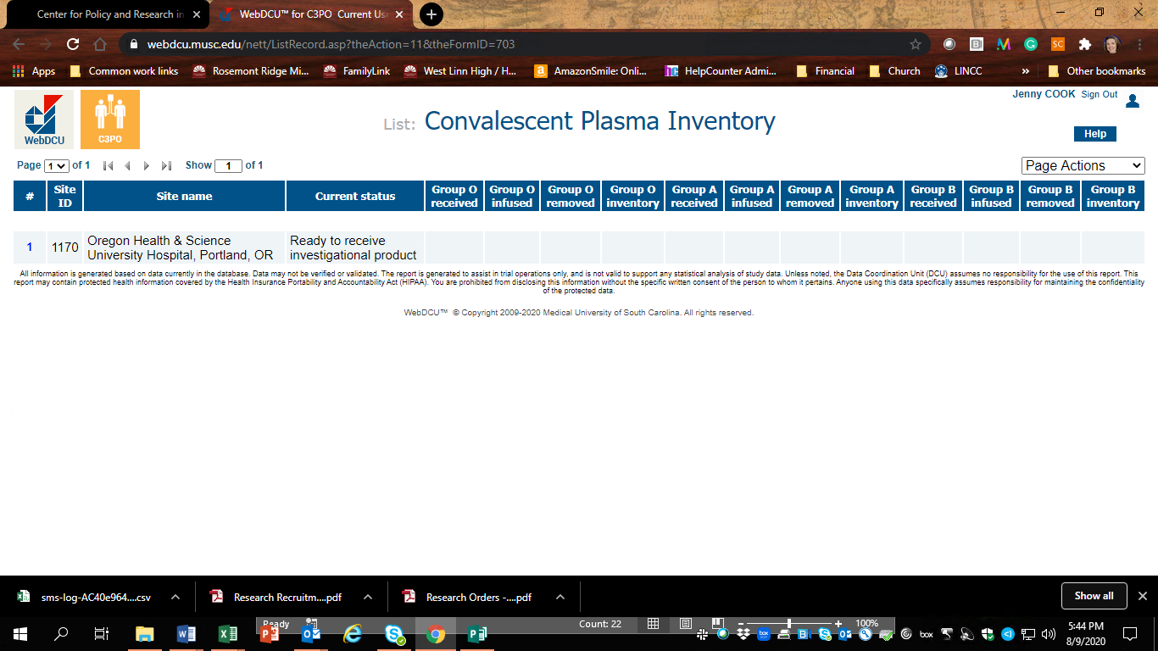

* Enter WebDCU Subject Enrollment form (WebDCU🡪C3PO🡪Add a new subject)
  + Add the REDCap-generated Consent ID into the enrollment form
* Complete Form 106: Medical History
* Complete Form 504 Symptom Inventory
* Complete Form 101 Eligibility
* Complete Form 102 Randomization

## **Add Research Association in EPIC**

[How to Place a Research Association in EPIC](https://bridge.ohsu.edu/cs/itg/projects/eri/_layouts/15/WopiFrame.aspx?sourcedoc=%7bB0660FFE-8F5E-48C6-9A1B-5411AEC40B21%7d&file=How%20to%20Place%20a%20Research%20Association%20on%20a%20Patient.docx&action=default)

* Research Studies Tab🡪Find Patient🡪In the Research Studies Activities enter: IRB 21734🡪Choose status: **Active**

## **IF ASSIGNED TO CP**

**Place order for C3PO CP through this order: GEN: COVID-19 Treatment: Adult and Ped**

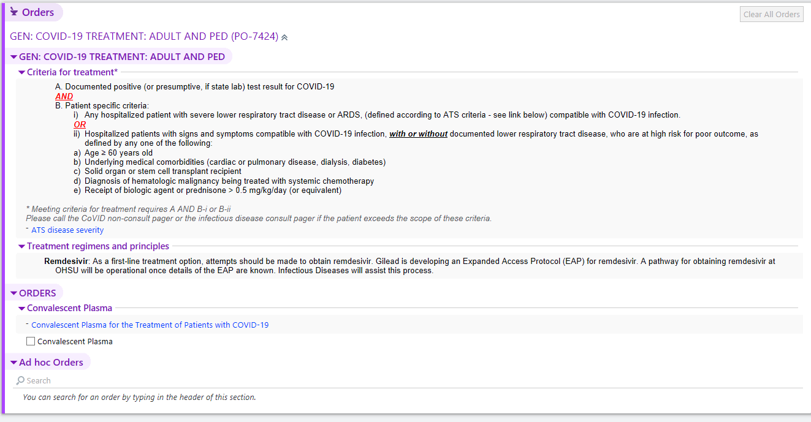

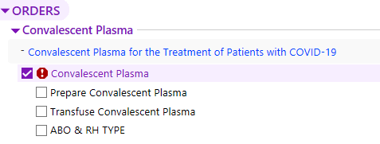

**Check this box**

Choose these options.

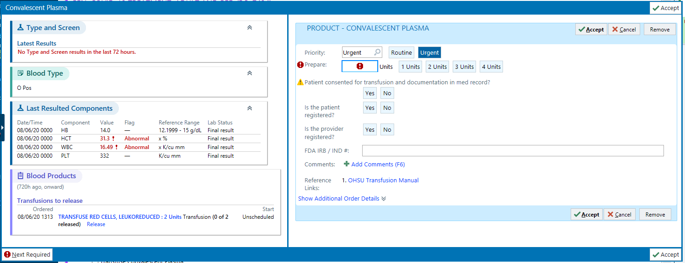

21734 C3PO

Then check this box.



**Check this box**

Choose these options.

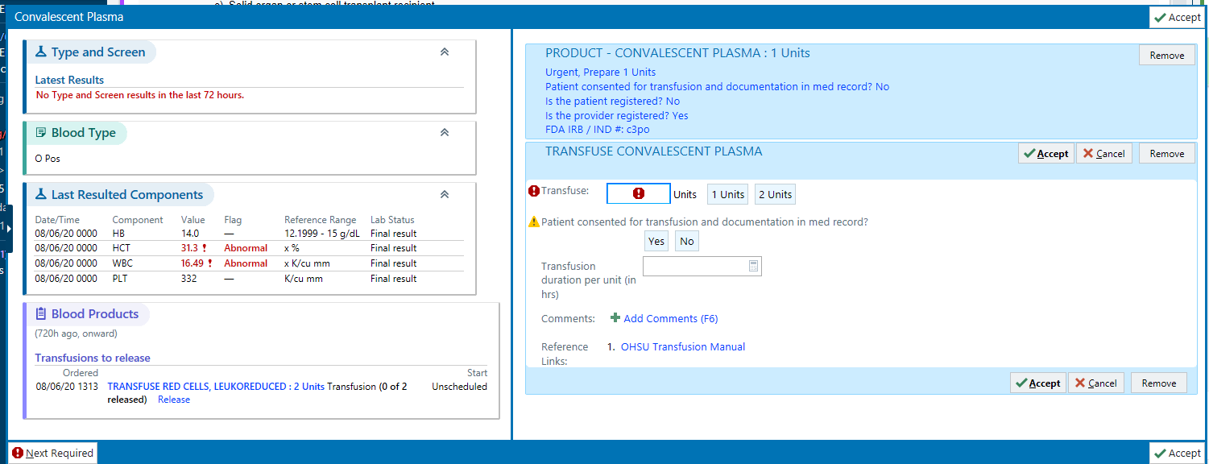

30 min

* 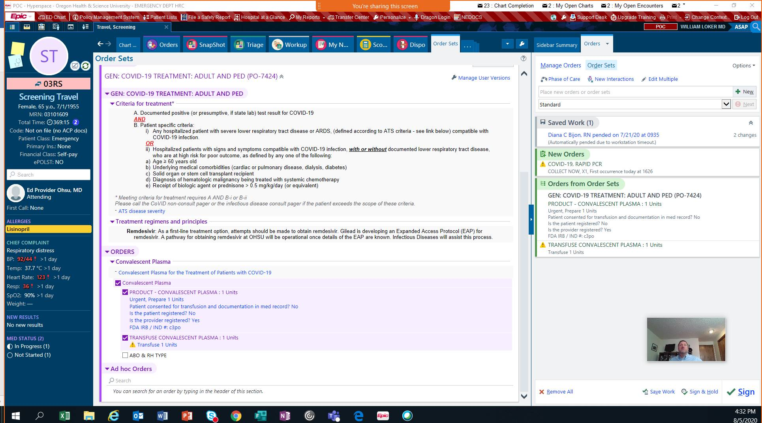Confirm with ED Provider they **add a research association** study when they sign the order 🡪located in the “Options” menu

Optional Meal Order

EPIC order IRB 21734 – C3PO contains meal options for the subject. Remind the RN they have the option of ordering a meal for the subject .

## **IF ASSIGNED PLACEBO**

**Place order for Placebo through this order: IRB 21734– C3PO (Research Emergency Medicine)**



**Check this box**

You will only need to add the Exception Code.

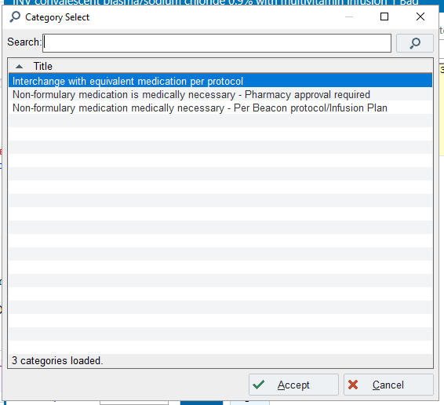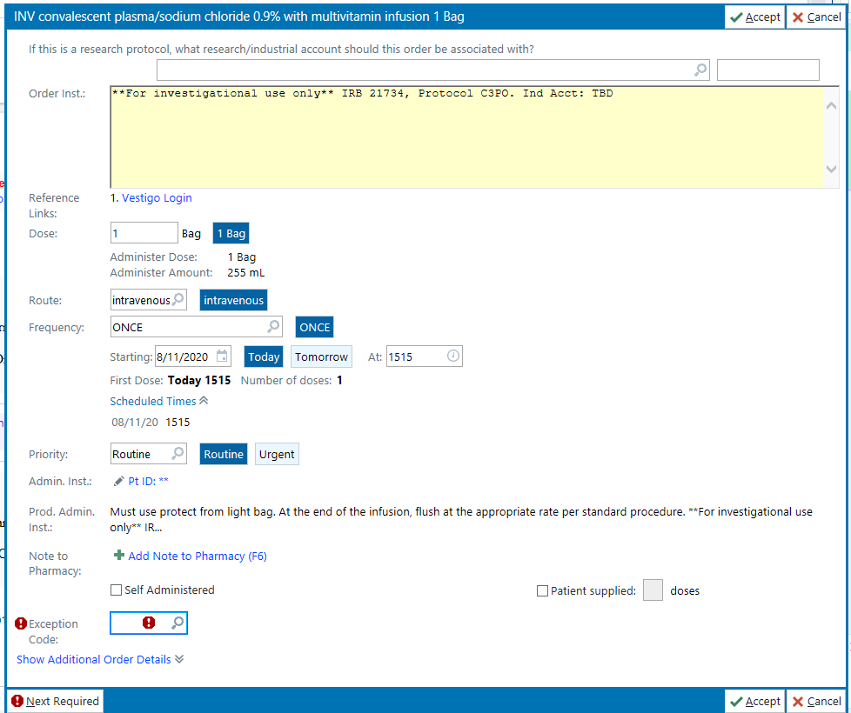

Sign & Hold order. If you are unable to do this, please see a provider to assist with placing this order.

## **Enter Subject Contact Information in RedCap Database (Can be completed whenever you have time after consent)**

* [Instructions for registering](https://docs.google.com/document/d/1gg6uhACPv0ffJ2nxKIHOw79bPOtocv_QomVNG2baaZ8/edit)

## **BEFORE THE SUBJECT DISCHARGES HOME**

* Complete the data form with names, times, and subject contact information.
* Give Trauma Research business card with expected dates for Day 15 and Day 30 visits & subject d/c handouts