Hyperbaric Oxygen
What is it and why is it used for Traumatic Brain Injuries?
What does “Hyperbaric” mean and what is “Hyperbaric Oxygen”?
The word “Hyperbaric” is really two short (abbreviated) words, Hyper + baric. “Hyper” means increased or higher and “baric” refers to the earth’s atmospheric pressure. In other words, hyperbaric simply means an increased or higher atmospheric pressure.
“Hyperbaric oxygen” means that 100% pure oxygen is being delivered to the patient at a pressure that is greater than the normal atmospheric pressure.
“Hyperbaric oxygen therapy” (HBOT) is a very common treatment that is provided at hundreds of hospitals throughout the United States and around the world. Thousands of these treatments are performed yearly in the United States to help patients recover from a variety of illnesses or injuries.
What is a Hyperbaric Chamber?
Hyperbaric chambers are specially designed medical devices that can deliver oxygen at a pressure that is higher than the atmospheric pressure we experience every day. For treatments, patients are placed inside a “hyperbaric chamber” and the chamber is pressurized while the patient breathes pure 100% oxygen. Hyperbaric chambers are in different sizes.
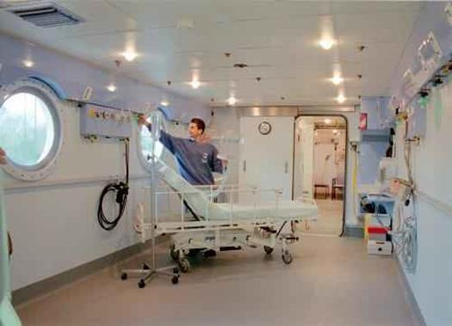
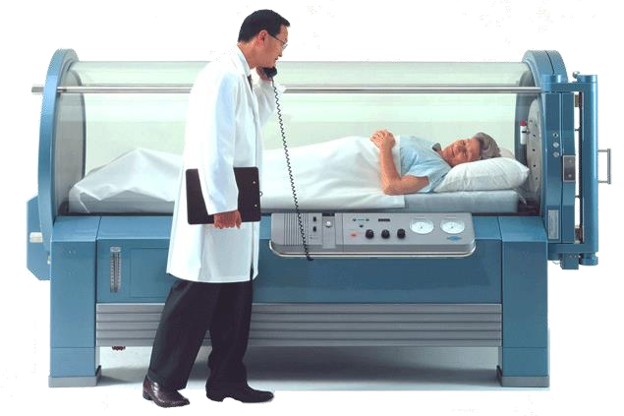
Single person Monoplace Hyperbaric Chamber Whole room Multiplace Hyperbaric Chamber
Both types of chambers are safe and commonly used throughout the United States.
Specially trained hyperbaric techs and nurses along with a supervising hyperbaric medical doctor will care for each patient being treated in the hyperbaric chamber.
Will my loved one feel any pressure while in the hyperbaric oxygen chamber?
The simple answer is, “No”. Being inside the Hyperbaric Oxygen Chamber feels similar to being under water; your body does not feel the changing pressures. However, in areas like your ears, where there is an enclosed air space, some people may feel the pressure changes. To prevent ear pain in an unconscious subject treated in a hyperbaric chamber, a doctor will put a very small hole in the patient’s ear drum to even out pressure changes. This procedure is called a “myringotomy”. The small hole in the ear drum will naturally heal after the hyperbaric treatments are completed.
How does Hyperbaric Medicine work and why use it for Traumatic Brain Injury?
When a subject is placed inside of a hyperbaric chamber, the atmosphere inside the chamber is increased or pressurized 1 ½ to 2 ½ times the earth’s normal atmospheric pressure. As pressure in the chamber increases, the oxygen that the subject breathes also becomes more concentrated, therefore the subject is able to get more oxygen.
Previous studies have shown that hyperbaric oxygen protects brain cells from additional injury and death following severe Traumatic Brain Injury (TBI). There have been three similar, but smaller studies using Hyperbaric Oxygen to treat TBI completed over the last 20 years. Those small studies have suggested that hyperbaric oxygen could be a beneficial treatment for individuals who have suffered a severe acute TBI. This study will determine whether there is a beneficial effect of Hyperbaric Oxygen treatment in TBI patients and if so, what is the most effective way to deliver the treatment.

