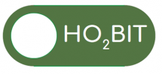

Hyperbaric Oxygen Brain Injury Treatment (HOBIT) Trial

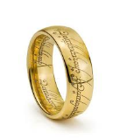

HOBIT patients are precious!

Call Dr. XXXX and the study team for patients with:

Blunt head injury in the last 24 hours

GCS post-resuscitation and off sedatives and paralytics should 3-8 (motor score=5 for intubated patients)

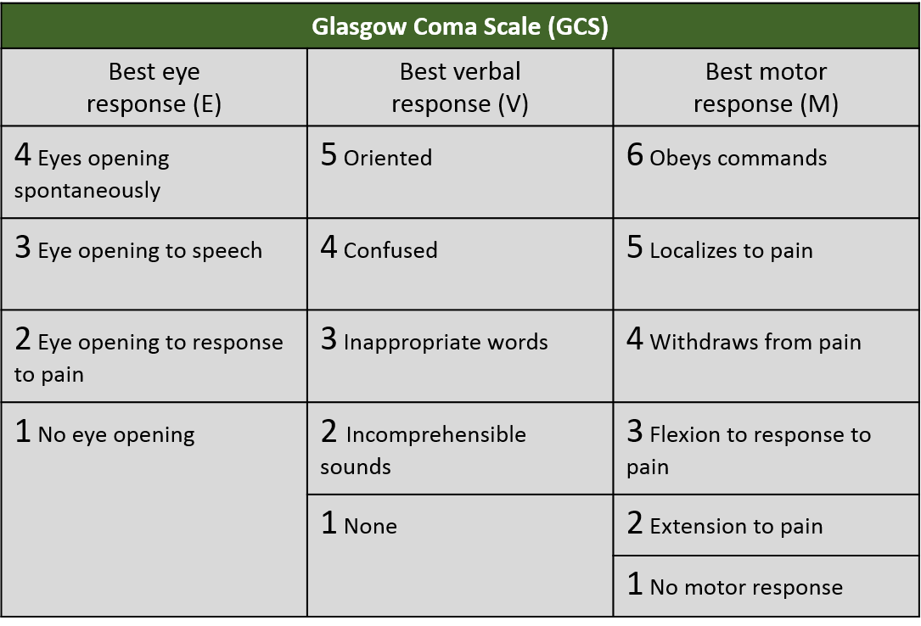Call XXX-XXX-XXXX